|  |
| --- |
| Close-up image showing the leaf-sides of two oversized books side-by-side on a bookshelf, with additional books in soft focus background |
| Software Design and Architecture  LAB TASK 02 |
| |  |  |  | | --- | --- | --- | | Muneeb Khan | 10/15/24 | SDA | |

# Use Case Diagram:

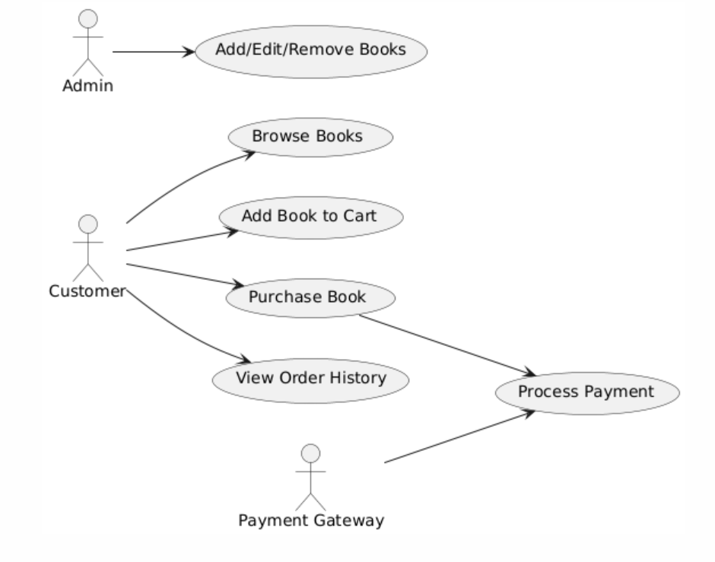

# Fully Dressed Use Case Diagram:

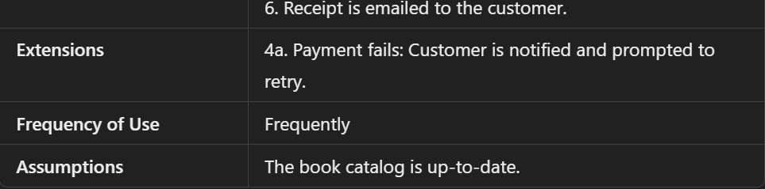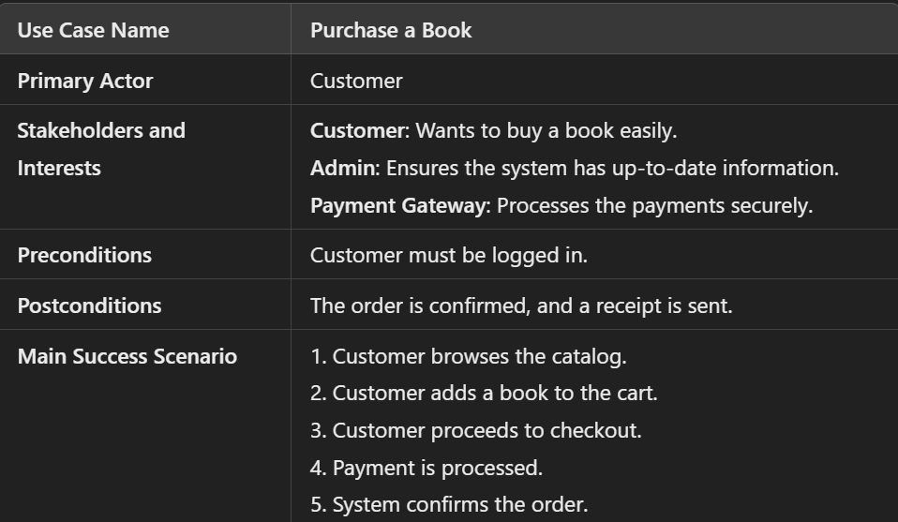

# System Sequence Diagram:

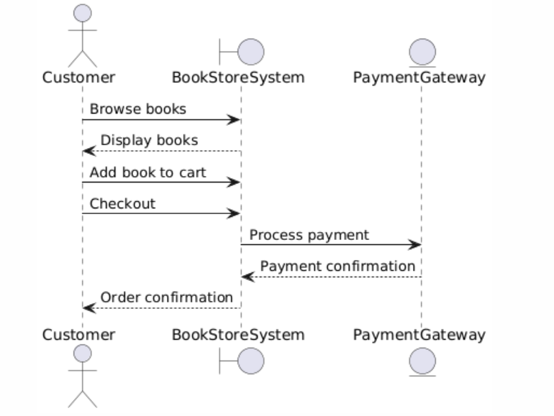

# Class Diagram:

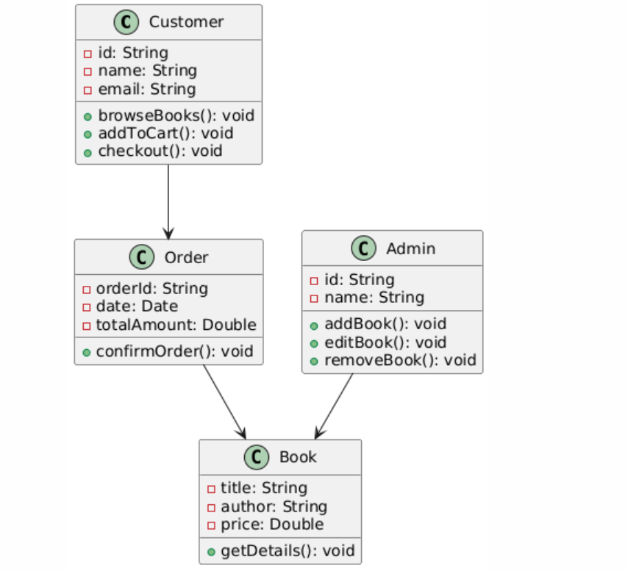

# Communication Diagram:

